**DEPARTMENT OF ELECTRONIC AND TELECOMMUNICATION ENGINEERING**

**UNIVERSITY OF MORATUWA**



**EN3150 Assignment 01**

Learning from data and related

challenges and linear models for regression

**PUSHPAKUMARA H.M.R.M.**

**200488E**

September 11, 2023

# Data preprocessing

1. Index Number: 200488E. I used 200488 to generate customized data.

2. Generated data

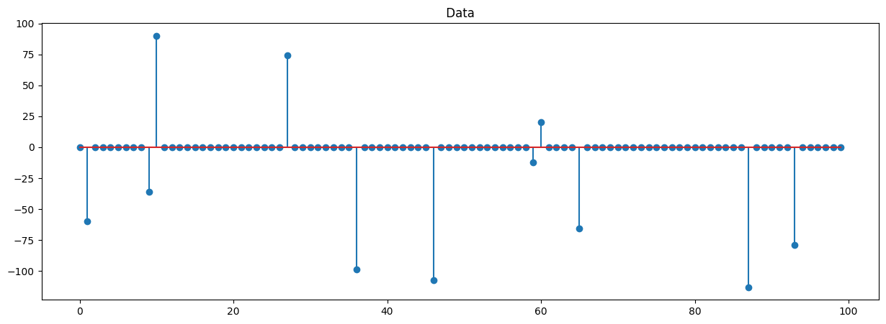

3,4. **MaxAbsScaler**

**Min-Max Scaler**

**Standard Scaler**

5. Number of non-zero elements in the signal **before normalization**: 11

Number of non-zero elements in signal after **MaxAbs normalization**: 11

Number of non-zero elements in signal after **MinMax normalization**: 99

Number of non-zero elements in signal after **Standard normalization**: 100

6. **MaxAbsScaler**

MaxAbsScaler scales each feature by its maximum absolute value. It essentially divides each feature by the maximum absolute value present in that feature. This scaling technique is useful when our data contains both positive and negative values and we want to maintain the original sign of the data.

MaxAbsScaler is often used when the distribution of the data is not necessarily Gaussian and when the data has outliers.

**Min-Max Scaler**

Min-Max Scaler, also known as Min-Max normalization, scales features to a specified range, typically between 0 and 1. It linearly transforms each feature so that the minimum value becomes 0, and the maximum value becomes 1, with values in between scaled proportionally.

Min-Max Scaler is widely used when you want to scale features to a common range and maintain the relationships between data points. It is especially useful when you have features with different units or scales.

**Standard Scaler**

Standard Scaler standardizes features by subtracting the mean and dividing by the standard deviation of each feature. This transformation results in each feature having a mean of 0 and a standard deviation of 1. It assumes that the data follows a Gaussian (normal) distribution.

Standard Scaler is commonly used when your data has a Gaussian distribution, and you want to center the data around zero with unit variance. It's useful for many machine learning algorithms that assume standardized data.

7. **MaxAbsScaler**

**Scaling Range:** The data is scaled within the range [-1, 1] because it divides each feature by its maximum absolute value.

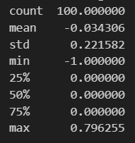**Impact on Structure:**

Mean: The mean is shifted closer to 0 but still retains the same sign as the original data.

Standard Deviation: Reduced to a fraction of the original, making the data less spread out.

Min and Max: Scaled within the [-1, 1] range.

Percentiles: The percentiles retain their relative positions but are scaled to the [-1, 1] range.

Overall Impact: MaxAbsScaler maintains the data's relative relationships and signs while significantly reducing the magnitude. It's suitable when preserving the sign and relative magnitude is important, but it doesn't preserve the original scale.

**Min-Max Scaler**

**Scaling Range**: The data is scaled within the range [0, 1] because it linearly transforms each feature to this range.

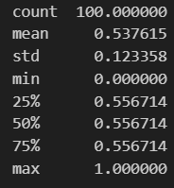**Impact on Structure:**

Mean: The mean is shifted to a value between 0 and 1.

Standard Deviation: Reduced to a fraction of the original, making the data less spread out within [0, 1].

Min and Max: Transformed to 0 and 1, respectively.

Percentiles: The percentiles retain their relative positions but are scaled to the [0, 1] range.

Overall Impact: MinMaxScaler scales the data proportionally within a bounded range [0, 1], preserving relative relationships while enforcing the new scale.

**Standard Scaler**

**Scaling Range:** The data is scaled to have a mean of 0 and a standard deviation of 1.

**Impact on Structure:**

Mean: Centered around 0.

Standard Deviation: Scaled to 1.

Min and Max: Outliers may be significantly below -3 or above 3, suggesting a departure from the normal distribution.

Percentiles: Shifted and scaled to be centered around 0 with a standard deviation of 1.

Overall Impact: Standard Scaler significantly changes the scale and distribution of the data, centering it around zero with unit variance. It may not preserve the original data's distribution or relative relationships.

# Linear regression on real-world data

1.

|  |  |  |  |  |  |
| --- | --- | --- | --- | --- | --- |
| Sample | Index | TV | Radio | Newspaper | Sales |
| 0 | 1 | 230.1 | 37.8 | 69.2 | 22.1 |
| 1 | 2 | 44.5 | 39.3 | 45.1 | 10.4 |
| 2 | 3 | 17.2 | 45.9 | 69.3 | 9.3 |
| 3 | 4 | 151.5 | 41.3 | 58.5 | 18.5 |
| 4 | 5 | 180.8 | 10.8 | 58.4 | 12.9 |

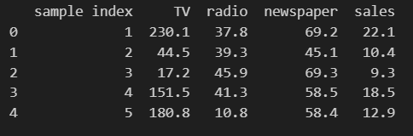

2. 

3.

**y = w0 + w1x1 + w2x2 + w3x3**

Model Parameters;

w0 = 2.907947020816433 (Intercept)

w1= 0.0468431

w2 = 0.17854434

w3 = 0.00258619

4.

|  |  |  |
| --- | --- | --- |
| Statistics | For Training | For Testing |
| Residual sum of squares (RSS) | 482.6928972255484 | 79.67542207315162 |
| Residual Standard Error (RSE) | 1.7590296298315473 | 0.7146606782832712 |
| Mean Squared Error (MSE) | 3.0168306076596774 | 0.49797138795719764 |
| R2 statistic | 0.8959372632325174 | 0.8927605914615384 |

For training data

|  |  |  |  |
| --- | --- | --- | --- |
|  | Standard Error | t-statistic | p-value |
| w0 | 0.2657589245679816 | 10.942048420551066 | 0.0 |
| TV | 0.0015915882844085901 | 29.431671265660643 | 0.0 |
| radio | 0.009153205539098987 | 19.506209387105205 | 0.0 |
| newspaper | 0.006616785718567478 | 0.3908523267924272 | 0.6964396551006735 |

For testing data

|  |  |  |  |
| --- | --- | --- | --- |
|  | Standard Error | t-statistic | p-value |
| w0 | 0.25523244755384117 | 11.393328115944204 | 0.0 |
| TV | 0.001499017049088985 | 31.24921307963703 | 0.0 |
| radio | 0.008583483986745346 | 20.800917679183065 | 0.0 |
| newspaper | 0.004669375784666661 | 0.5538612039925214 | 0.5804668591108091 |

6. Based on the statistics for training and testing data, it appears that there is a relationship between advertising budgets (TV, radio, and newspaper) and sales. Because,

1. **R2 statistic:** The R2 statistic (coefficient of determination) measures the proportion of the variance in the dependent variable (sales) that is explained by the independent variables (advertising budgets). In both the training and testing data sets, the R2 statistic is close to 1, which indicates a strong relationship between advertising budgets and sales. Specifically, the training data has an R2 of approximately 0.896, and the testing data has an R2 of approximately 0.893.
2. **p-values for coefficients:** In both the training and testing data, the p-values for the coefficients of TV and radio are very close to zero (p ≈ 0.0), which suggests that these variables are statistically significant predictors of sales. The p-values for newspaper are higher but still relatively low (p ≈ 0.696 for training and p ≈ 0.580 for testing), indicating that it may also have some influence on sales.
3. **T-statistics:** The t-statistics for TV and radio in both the training and testing data are significantly different from zero, with high absolute values. This indicates that the coefficients for these variables are highly statistically significant.
4. **Standard Errors:** The standard errors for TV and radio are relatively low, indicating that the estimated coefficients for these variables are precise and reliable.

7. Based on the statistics, it appears that the independent variable "TV" contributes highly to sales. Because,

1. **Coefficient Significance:** The p-value for the coefficient of "TV" is very close to zero (p ≈ 0.0) for both the training and testing data. A low p-value indicates that the coefficient is statistically significant.
2. **T-statistic:** The t-statistic for "TV" is significantly different from zero, with a high absolute value. A high t-statistic suggests that the coefficient for "TV" is highly statistically significant.
3. **R2 Statistic:** The R2 statistic, which measures the proportion of variance in sales explained by the independent variables, is relatively high for "TV" in both the training and testing data sets (close to 0.896 and 0.893, respectively). This indicates a strong relationship between "TV" and sales.
4. **Standard Error:** The standard error for "TV" is relatively low, indicating that the estimated coefficient for "TV" is precise and reliable.

We can see this when we plot features vs. sales.

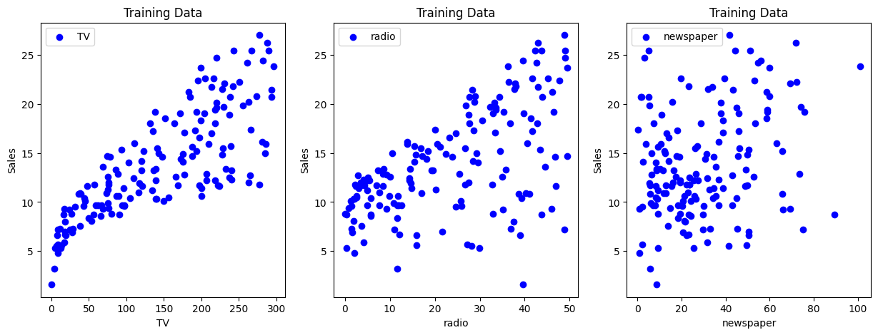

7. 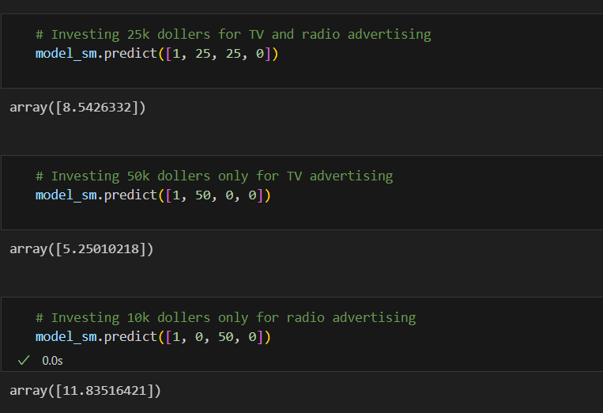

According to model prediction,

* 1. If we allocate 25,000 dollars for TV and radio it shows 8542 sales.
  2. If we allocate 50,000 dollars only for TV, it shows 5250 sales.
  3. If we allocate 50,000 dollars only for radio, it shows 11835 sales.

Therefore, according to our model, allocating 25,000 dollars for TV and radio equally doesn’t yield higher sales compared with allocating 50,000 dollars for radio only.

# Linear regression impact on outliers

1.

2.

**y = w0 + w1x**

where;

w0 = 3.916727272727277

w1 = -3.55727273

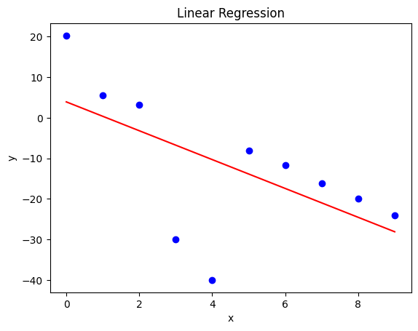

3. 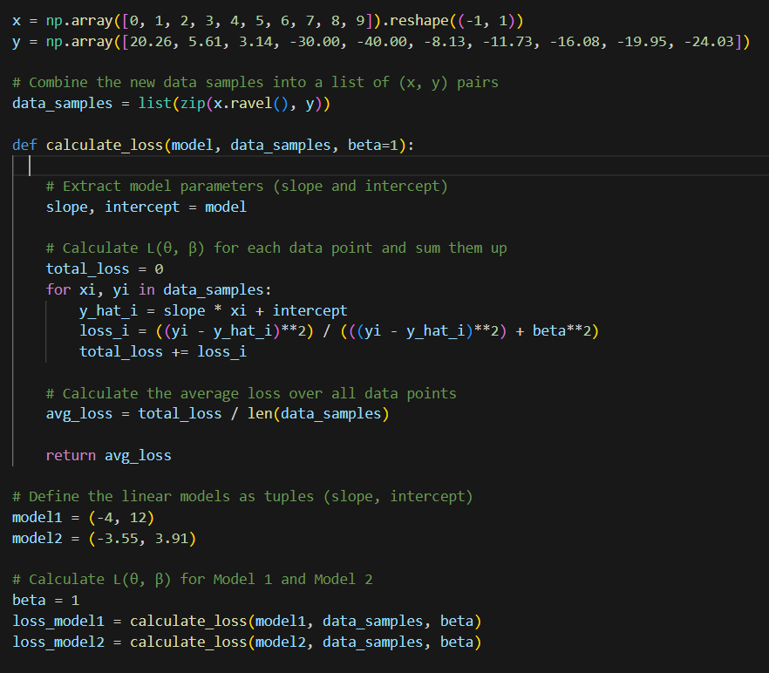

4. **For model 1**

L (θ, β) = 0.435416262490386

**For model 2**

L (θ, β) = 0.9728470518681676

5.

To determine the most suitable model for the provided dataset using the robust estimator, we need to select the model with the lowest loss function value (L(θ, β)). In this case, we have two models with their respective loss function values:

Model 1: L(θ, β) = 0.435416262490386, Model 2: L(θ, β) = 0.9728470518681676

The lower the loss function value, the better the model performs according to the robust estimator. Therefore, in this context, Model 1 is the most suitable model because it has the lowest loss function value (0.435416262490386) compared to Model 2 (0.9728470518681676).

Justification:

* The robust estimator is designed to minimize the impact of outliers and provide more reliable model parameter estimates. In this case, Model 1 has a significantly lower loss function value, indicating that it provides a better fit to the data and minimizes the impact of outliers better than Model 2.

Therefore, based on the loss function values and the goal of reducing the impact of outliers, Model 1 is the more suitable choice for the dataset.

6.

For data points with small residuals (i.e., data points that are close to the model's predictions), the denominator in the loss function is dominated by the squared residual term, and the weight assigned to these data points is relatively high.

For data points with large residuals (i.e., outliers), the denominator in the loss function is influenced by both the squared residual and β2. As β increases, the impact of the squared residual on the weight decreases, leading to a smaller weight for outliers.

By adjusting the value of β, you can control how much emphasis the loss function places on reducing the impact of outliers. Smaller values of β give more emphasis to robustness against outliers, while larger values of β make the loss function less robust.

7.

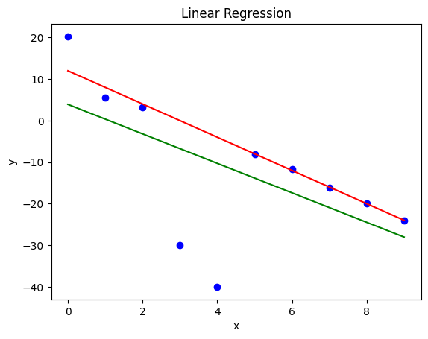

8.

The parameter β controls the impact of the denominator on the weighting. When β is small, the denominator is close to the squared residual, and the weight assigned to the data point is relatively high. When β is large, the denominator becomes closer to β2, reducing the weight assigned to the data point.